Home task 4

1. Design NFA which accepts all inputs with a 11 and also construct DFA.

SOLUTION:

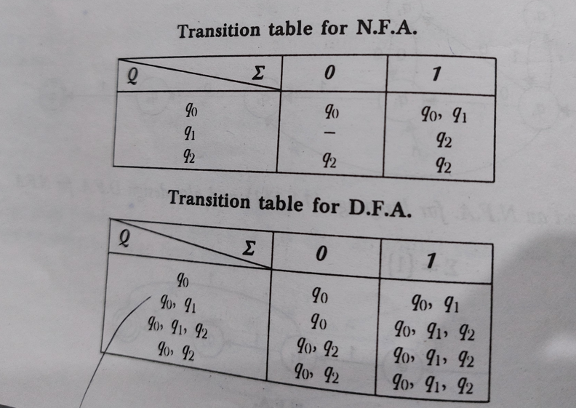

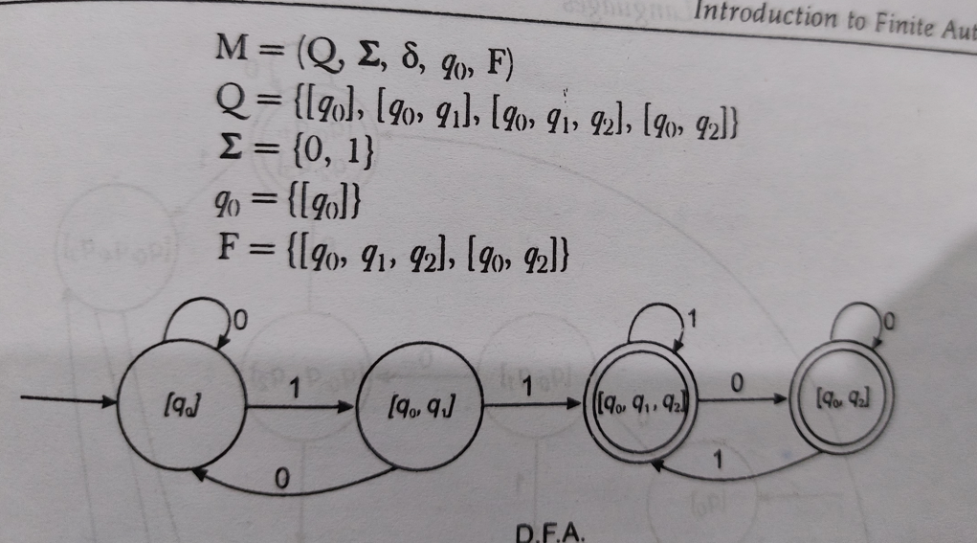

1. Design an NFA that accepts all inputs with a triple letter like 111 ,000.

SOLUTION.

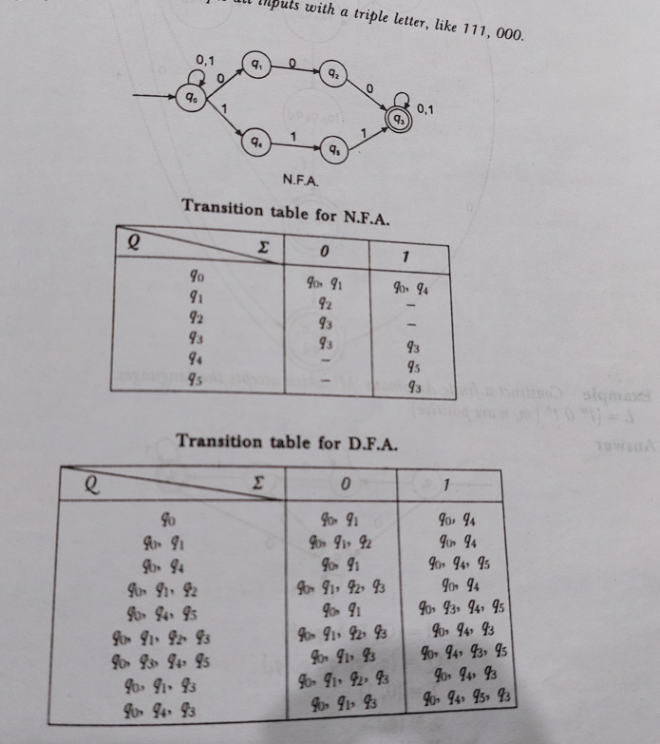

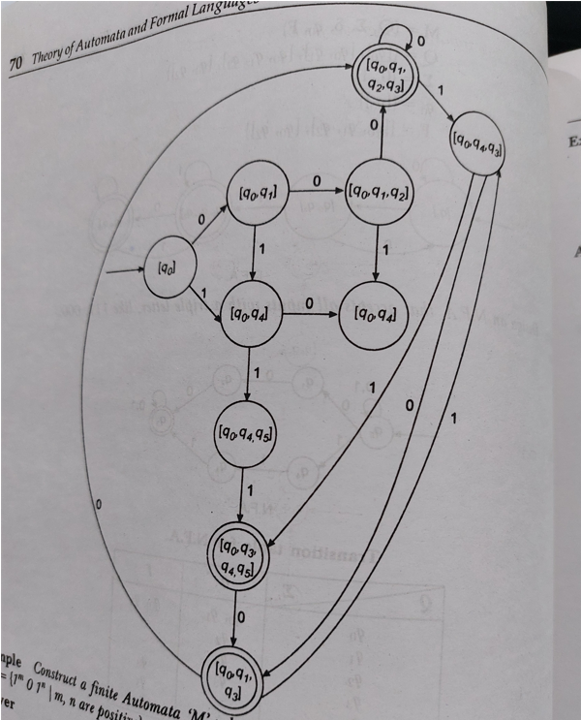

1. Convert the following NFA TO an equivalent DFA

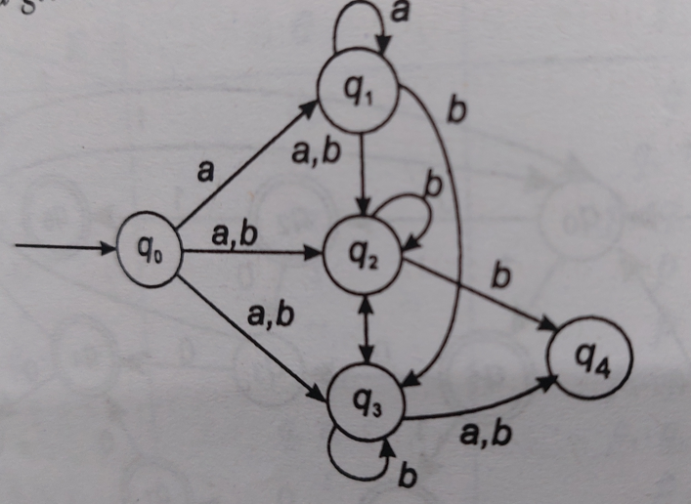

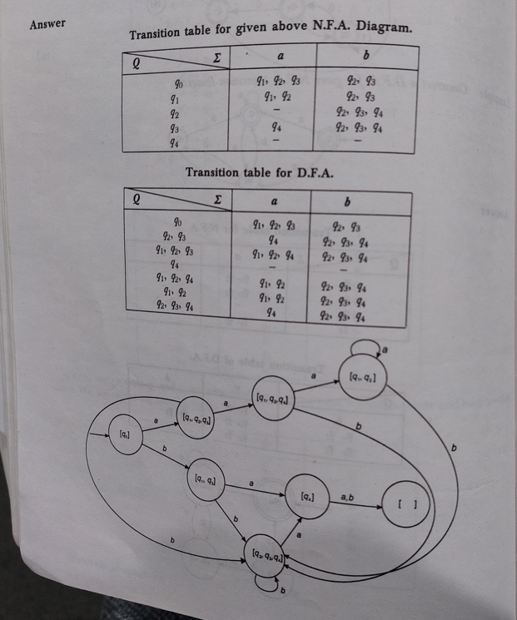

1. Convert the following Epsilon NFA TO an equivalent DFA

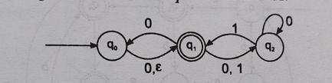

Solution

